Data definition

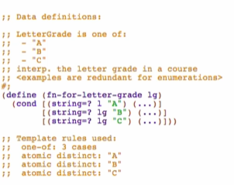

In real world:

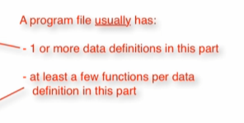

Function definition

**Signature, purpose, and stub**

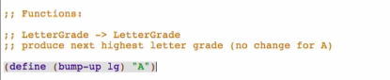

**Examples**

Recipe -> Enumerations -> Guidance on Data Examples and Function Example/Tests

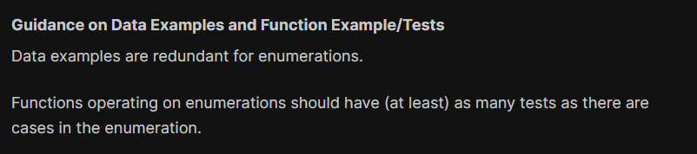

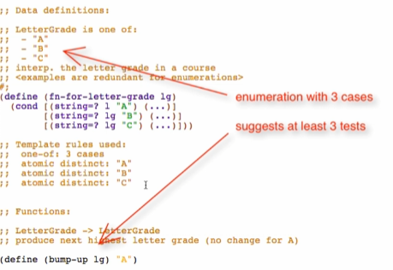



Run and make sure it’s well-formed

**Template**

Comment out stub and use template from data definition, rename the function name

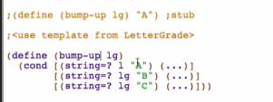

**Code Body**

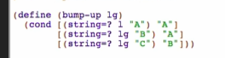

run and debug:

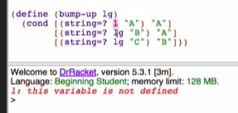

This is why we check the well-formedness of the template before we write any more code body, so we don’t copy bugs

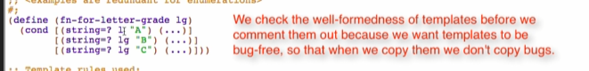

Enumeration

* Should have at least n test for n case enumeration